**How to run integration script**

|  |  |  |
| --- | --- | --- |
| **Version** | **Date** | **Changes** |
| 1.0 | 26.01.2021 | New development |
| 1.1 | 30.03.2021 | Biztalk EV for Custom type 1 under CAPITA REMOTE SYSTEM PARAMS, Parameter name - Remote system To is updated to use Biztalk host name from the Biztalk NE. This change is included in the EV function in the end for BIZTALK. |
| 2.0 | 16.04.2021 | Shortened the script and introduced the port functions |

1. Connect to the db server with oracle user.
2. Place both the files on DB server under /home/oracle/automation/integration.
3. Give integration.sh 700 permission (with oracle user only).

**Note: integration.sh file contains oracle_home/path as 19.0.0. In case the script is to be run on a different DB, please change the product version in the .sh script.**

**export ORACLE_HOME=/oracle/app/oracle/product/19.0.0/dbhome_1**

**export PATH=$PATH:/oracle/app/oracle/product/19.0.0/dbhome_1/bin**

1. Enter the integration points’ values in the points.csv file and leave blank for a specific integration point if there is no value to pass. The values are ; separated.

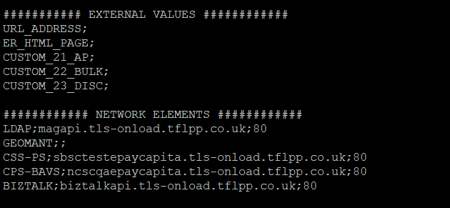

1. Run the integration.sh file (./integration.sh)

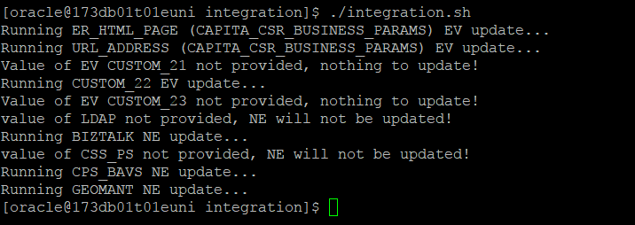

If there is no value provided in the points.csv file for a specific integration point, there will be no changes in the system for that.

**APPENDIX**

**URL_ADDRESS;<EV under CAPITA CSR BUSINESS PARAMS>**

**ER_HTML_PAGE;<EV under CAPITA CSR BUSINESS PARAMS>**

**CUSTOM_21;<REMOTE SYSTEM URL EV under CAPITA REMOTE SYSTEM PARAMS for custom type 21>**

**CUSTOM_22;<REMOTE SYSTEM URL EV under CAPITA REMOTE SYSTEM PARAMS for custom type 22>**

**CUSTOM_23;<REMOTE SYSTEM URL EV under CAPITA REMOTE SYSTEM PARAMS for custom type 23>**

**############ NETWORK ELEMENTS ############**

**LDAP;<LDAP NE host>**

**GEOMANT;<GEOMANT NE host>**

**CSS-PS;<CSS-PS NE host>**

**CPS-BAVS;<CPS-BAVS NE host>**

**BIZTALK;<BIZTALK NE host>**

Biztalk EV for Custom type 1 under CAPITA REMOTE SYSTEM PARAMS, Parameter name - Remote system To is updated to use Biztalk host name from the Biztalk NE